How to use the software for model training and segmentation

For model training

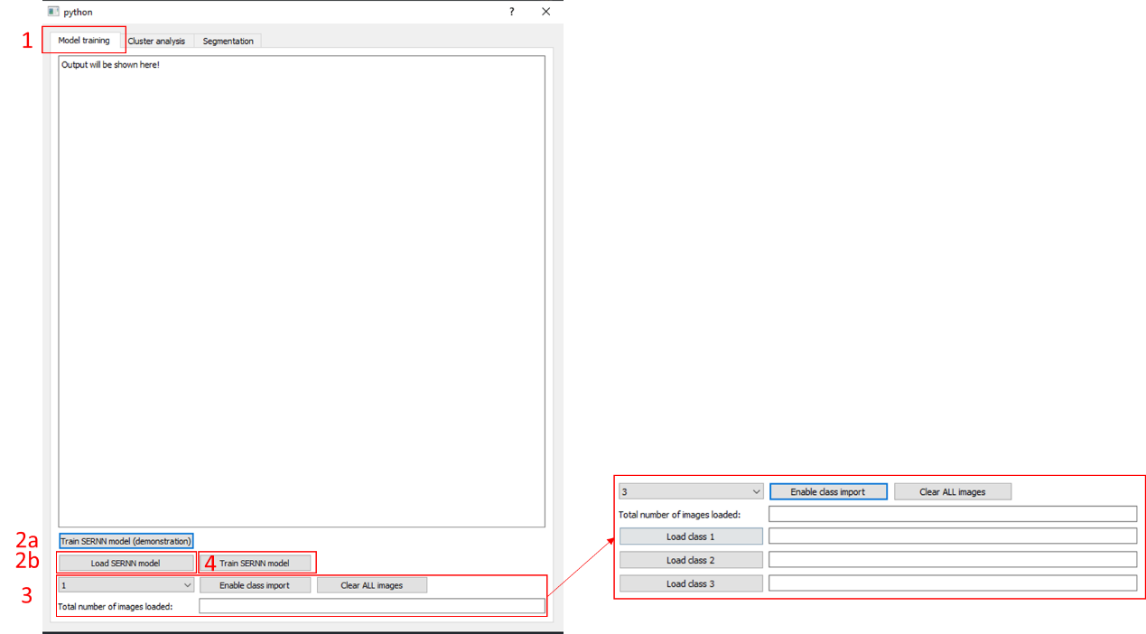

1. Ensure that the tab is set to “Model training”
2. You can click on the button “Train SERNN model (demonstration)” to perform the same training that was done in the study. On the other hand, you can also choose to modify the model by editing the script provided. After performing the necessary modifications, press on “Load SERNN model” and select the modified script.
3. Select the number of classes that you will be training – you can train up to a maximum of 3 classes. After selecting the number of classes, press “Enable class import” and the buttons to let you load the different classes of images will show up. The directories of the images will be shown in the empty message boxes. Click on “Clear ALL images” if you wish to reset the loading of images.
4. Once you have loaded both your model and images, press “Train SERNN model” to start the model training. Once the training is done, two files will be saved – one contains the trained model (“Trained_SERNN_model.h5”) and the other one contains only the trained weights (“Trained_SERNN_weights.h5”).

For segmentation of cellular components

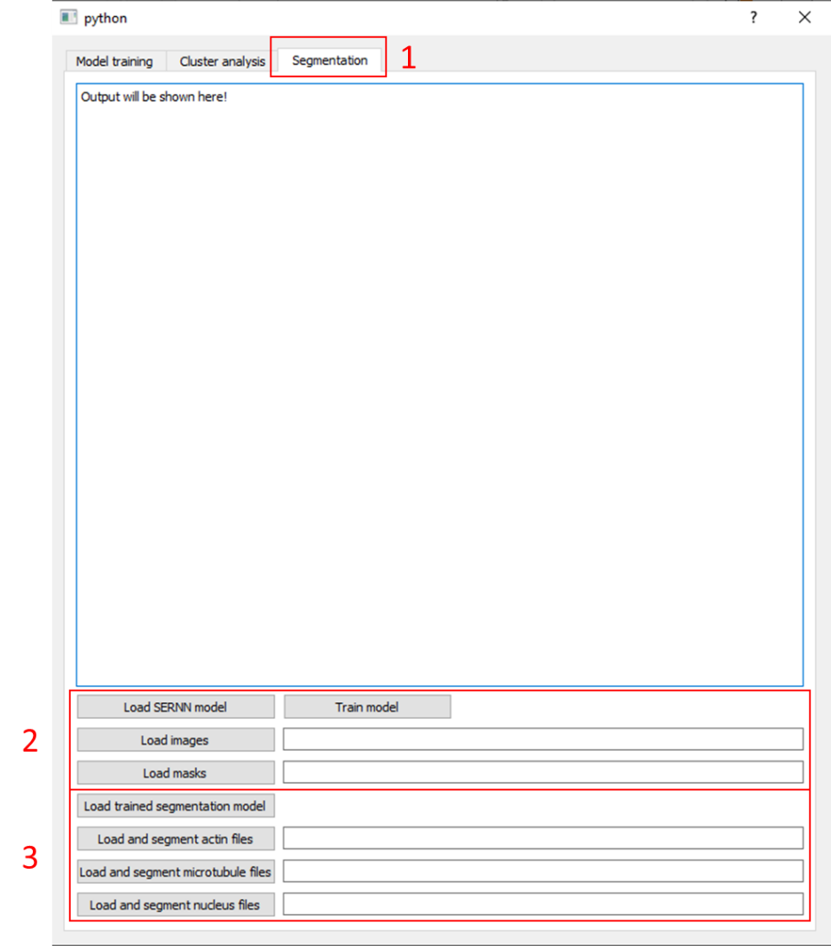

1. Ensure that the tab is set to “Segmentation”
2. You may choose to train your own segmentation using your own dataset. “Load SERNN model” loads the desired segmentation model. “Load images” and “Load masks” will load the training images and masks respectively. “Train model” will start the training of the segmentation model. Once the training has been completed, two files will be saved: “Trained_SERNN_segmentation_model.h5” which contains the trained model, and “Trained_SERNN_segmentation_weights.h5” which contains the trained weights.
3. Press on “Load trained segmentation model” to load the trained model. Use one of the remaining three tabs to load and segment the specific cellular component. For example, if you want to segment microtubules, press on “Load and segment microtubule files” and click on the folder containing the images to be segmented. A folder containing the segmented images will be saved.